**Music**

**John Lennon - much more than just a Beatle**

***John Lennon was assassinated in New York in December 1980 - just three months after the launch of Linguapress's Spectrum magazine. This retrospective, one of the oldest items on the Linguapress online archive, appeared in January 1981.***

The circumstances of the murder of John Lennon are well enough known for it to be unnecessary to repeat them now. It was ironic that John Lennon, **advocate** of non-violence, should have died the way he did : though perhaps it was ironic too that John should have chosen to live in New York, one of the more violent cities in the USA.  
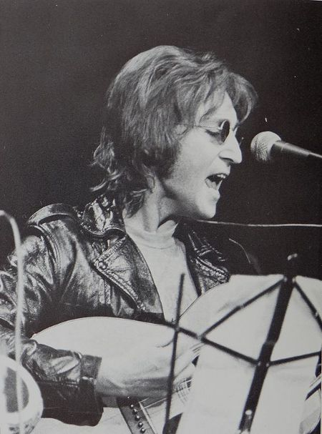     "lt could only have happened in New York," said one **stunned** fan, shortly after the news broke; that may or may not be true. That it did happen in New York certainly was. "lt's a part of our youth that has died," said someone else ; and tributes to John Lennon came in from people all over the world – from politicians, from musicians, from writers, from Englishmen, from Frenchmen, from Japanese people. There is probably no country in the world in which John's death did not come as a shock to some people. US president Ronald Reagan described it as "a great tragedy", and music radio-stations across the world played Lennon's songs, some of them in a non-stop tribute to the **former** Beatle who had such a tremendous effect on the world of the nineteen-sixties and early seventies.

**AN ACCIDENTAL HERO**

John Lennon never **set out to** become a hero, nor the leader of a whole generation. It came on him more by accident. He didn't want to be thought of as the *leader* of the Beatles — people forced it on him. "We're a co-operative" he used to say : but in the early nineteen sixties that was something people couldn't accept. "You must have a leader," they answered, and so John became the chief Beatle. He **deserved** the position, indeed, since he was the **founder** of the group, he wrote the words of most of their songs, and he was the dynamic force behind the others. "I'm just a **'uman bein'**" he used to say.  
   What was it therefore which made the Beatles what they were ? In short it was a combination of various things; their music, the words of their songs, their attitude, and their appearance.  
   Right from the start they were different; their music was good, and original; the words of their songs (Lennon's words) were often different. At the start Lennon wrote about love and romance, but it wasn't Hollywood love, it was 1960's everyday romance : something with which millions of young people in the cities of Britain and America, later Europe too, could identify. And in the nineteen sixties, there were millions and millions of teenagers and twenties just searching for something new to identify with. The expression "*generation****gap*"** was just becoming popular. The Beatles, led by Lennon, became the leaders of a new generation.  
     Forced into the role of leader, John Lennon accepted it, modestly. Even in 1970, he was still saying "l'm just a ’uman bein' " : but by then he knew he was a human being with influence; he knew that what he said or sung would be repeated all over the world. His songs had usually *said* something, right from the start; but in the period 1969-70, he began to say things more consciously. He had always been a symbol of an alternative life-style; but in the late 60s, his message became more **overt**. He wrote "Revolution", a song which classed him as peaceful, not violent, revolutionary, then there was his famous "Give Peace a Chance", and the more socially-conscious "Working-class Hero".  
   In fact, Lennon left the Beatles and the Beatles split up because they had "nothing more to say", **whereas** he had a lot. The Lennon of the early seventies was the most influential. He was "John Lennon", not just "a Beatle".  
   
    Shortly after the end of the Vietnam war, Lennon **retired from** public life. In a sense, the Beatles’ generation had managed, by then, to change the face of western society. Attitudes had become much more liberal, and pop music part of our culture.  
   Shortly before his death, John Lennon recorded another album; and the day he died, he had been in the recording studio. After five years of family life, he was returning to public life. Was it a need for more money ? Certainly not. Lennon was returning to life, perhaps, because he could see the world returning to its old ways. Re-armament, a return to conservatism, international tension, talk of war. The ex-leader of a generation which had tried to *give peace a chance*, could not sit back and watch things change for the worse. Tragically, in the end, peace would not give him a chance.

**WORDS**

**Advocate** : supporter, promoter - **Stunned** : shocked - **former** : ex- , one-time - **set out to:**planned to - **deserve** : merit - **founder** : creator - ’**uman bein'** (slang) : human being - **gap** : separation, distance - **overt** : frank, open - **whereas** : when (opposition) - **retired from**: left, quit.

**Student worksheet**

**John Lennon**

*Replace the missing modal verbs or auxiliaries in these extracts from the article*

Perhaps it was ironic too that John _______  ________ chosen to live in New York  
lt _________ only have happened in New York,  
That _____ or ______ not be true.  
"We're a co-operative" he __________ say :  
In the early nineteen sixties that was something people _______ accept.  
"You _______ have a leader," they answered,  
He knew that what he said or sung ______ _______ repeated all over the world.  
The Beatles’ generation ______ managed, by then, to change the face of western society.  
Tragically, in the end, peace _________ not give him a chance.

**USA - Music**

**Mississippi *Music***

*Though New York and Los Angeles are the current day capitals of the American music industry, it is half way between the two of them, in the*[***Mississippi***](https://linguapress.com/advanced/mighty-mississippi.htm)*Valley, that the roots of American popular music are to be found.*

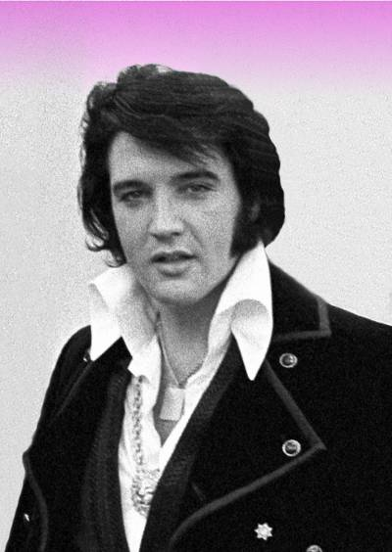

Elvis Presley - surely the most famous musician to have his roots in the Mississippi valley

    There are six classic forms of American popular music; jazz, the blues, bluegrass, soul, rock 'n' roll, and country and western.  
    With the exception of bluegrass and country and western, the Mississippi valley is the birthplace of them all.  
    Like American culture in general, American music has **evolved** out of the different traditions that reached the New World from the old. But out of all the different types of music that reached the New World - from England, Ireland, Spain, France, Germany, Africa and many other places - one was to have a particularly significant impact: African music.  
    While European influences provided melody and a **lyric** tradition, African influences added a new sense of rhythm and new harmonies, which were to **give rise to** several new forms of music that were different from anything European.  
    New American forms of music developed among the **slave** communities working in the cotton fields near the mouth of the Mississippi; Christianized slaves developed **gospel** music and Negro Spirituals, which soon became popular far beyond the rural states of the South.  
    Following **emancipation**, Blacks had much more opportunity to develop their musical talents, and many did exactly that, adding instrumentation to the essentially vocal tradition of the spiritual.  
    From the Spanish musical tradition they added the guitar, a popular instrument in the southern states which had been originally colonized by the Spanish. From a more general European tradition they added **brass** instruments such as trumpets, which were popular with the marching bands used at all kinds of ceremonial events in the American states.  
    It was thus in the late nineteenth century that two new forms of American music began to develop, both of them in the Mississippi valley.  
    Firstly there was the blues. In the cotton-growing Delta region of the state of Mississippi (not to be confused with the Mississippi Delta), the blues appeared in the 1870's, sometimes as a purely vocal tradition, at other times using the guitar as accompaniment. It was a form of music through which poor exploited Blacks expressed their sadness and their problems, their "blues". The sadness of the blues is evident both in the music itself, and in the titles of **countless** popular blues songs, such as *Poor Boy Blues*,*Homesick Blues* and many many others.

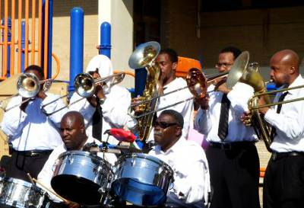

Traditional jazz band

    Jazz, on the other hand, developed in and around [**New Orleans**](https://linguapress.com/advanced/mardi-gras-orleans.htm), as a type of music for festive moments and dancing. The most famous jazzman of all, Louis Armstrong (Satchmo) was born in New Orleans.  
    Both of these forms of music migrated up the Mississippi valley with the Blacks who went north in search of work in the early twentieth century. Satchmo was one of them; he went north, ending up in Chicago, where his "New Orleans Jazzmen" soon established a national reputation, thanks to the development of both radio and the gramophone.  
    In the 1920's, many of the Blacks who migrated north went looking for jobs in the booming American automobile industry, in and around  Detroit, and it was here in "Motown", i.e. mo(tor) town, that soul music and other new varieties evolved.  
    With the advent of radio and records, all varieties of black music became increasingly popular. In the north Detroit became the capital of soul music; in the south New Orleans remained the capital of jazz; and between the two, at the heart of the Mississippi valley, Memphis became the center for an exciting new type of music; rhythm 'n' blues.  
    This music soon attracted the attention not just of Blacks but of Whites too; and with very little change, R & B evolved into yet another new type of music; rock 'n' roll.

**Elvis Presley**

    The man who did most to help rock 'n' roll conquer first America, then the world, was in fact not a black musician, but a white boy from rural Mississippi, by the name of Elvis Aaron Presley. Elvis's family were poor, very poor; as a kid, Elvis lived in a two-room **shack** in Tupelo, Mississippi. There was not much to distinguish the lifestyle of his poor white family from that of the equally poor black families in the region, and young Elvis had plenty of contact with black culture and music.  
    After making his first records in Memphis, Elvis became the biggest rock star the world had ever seen; "the King". Yet he never abandoned his Mississippi valley roots, and it was in Memphis that he established his famous home, Graceland.  
    In the space of the last forty years, rock 'n' roll has become the basis of popular music worldwide. In this respect, it could be argued that the Mississippi valley is the source of the greatest cultural phenomenon of the twentieth century.

**WORDS:**

**evolve:** develop - **lyric**: music that tells a story - **give rise to:**create - **slave**: unpaid worker - **gospel**: parts of the bible - **emancipation**: freeing of the slaves - **brass**: a yellow metal - **countless**: innumerable - **shack**: poorly-built house.

**Mississippi Music -  Exercises**

Read through the article, then decide if these statements are right (R) or wrong (W). Rewrite any wrong statements, correcting them as necessary.

1.    The roots of American popular music are mainly African and Caribbean.  R W  
2.    Gospel music first developed in the south of the United States.  R W  
3.    American slaves often played the guitar as they sang in the fields.  R W  
4.    Some of the first blues musicians sang unaccompanied.  R W  
5.    Jazz originated with Louis Armstrong in Chicago.  R W  
6.    Many Blacks headed north to Detroit because it was the capital of soul music.  R W  
7.    Elvis Presley invented rock 'n' roll.  R W  
8.    The city of Memphis can claim to be the birthplace of modern rock music.  R W

# Mardi Gras

## *in New Orleans*

*New Orleans, the great city at the mouth of the*[***Mississippi***](https://linguapress.com/advanced/mighty-mississippi.htm)*is one of the most colorful, most cosmopolitan and most European of American cities.  
    Though very few people in the city now speak or understand much French, New Orleans prides itself on its French heritage. The historic center of the city is known as the French Quarter, and the city is famous across the United States for its restaurants and its "Mardi Gras" celebrations.  
    It is still one of America's great ports, where goods that have traveled down the Mississippi valley by barge or by truck or by train are offloaded and trans-shipped, to be exported all over the world.*

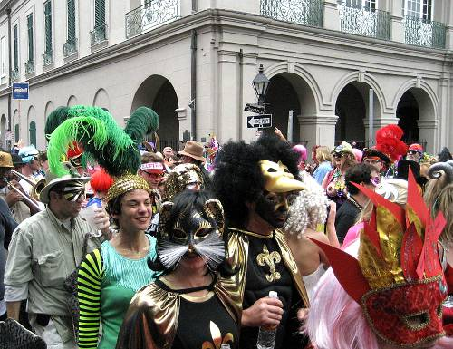

Mardi Gras parade in New Orleans

By **John Robillard**  
  
      Mardi Gras, meaning literally "Fat Tuesday" was first celebrated in Louisiana by French colonists in the eighteenth century. It was, in those days, a day of feasting before the start of *Lent*, the 40-day period leading up to Easter.  
    As the last "normal" day before the austerity of Lent, "fat Tuesday" was a day **to make the most of**, a day of carnivals, eating, drinking and **revelry**. It has remained a day of carnival ever since; but the original French celebrations are just a small part of today's festivities. Mardi Gras, New Orleans style, owes as much to Afro-Caribbean **customs** and the Latin American carnival tradition as it does to the French colonists who established it in their new city.  
    The Mardi Gras celebrations actually **last** for several weeks. About a month before the main carnival, a season of elaborate balls and parties begins: the official Mardi Gras program is published, and shops start selling the very sweet and colorful "King Cake", a delicacy that can only be found during this holiday season.  
    In other parts of Louisiana, the first Mardi Gras parades actually take place three to four weeks before the big carnival in New Orleans, and even in the city itself, smaller parades begin two weeks before the big day.  
    My first Mardi Gras party took place in a friend's apartment in New Orleans a few days before the parade. The apartment was decorated out in the season's traditional colors of green, gold and purple; the hi-fi system pounded out carnival music, while the guests danced, talked, and ate King Cake, washed down with "Blackened Voodoo Beer", another specialty **brewed** in a local brewery.  
    On Fat Tuesday itself, I joined the hundreds of thousands of local people and visitors, to watch the processions **wind their way** through the streets of New Orleans. The processions are organized by groups called "Krewes", which each have mythological or historic names, such as Proteus, Endemion, or Bacchus. The one I liked best was Zulu, a parade organized by members of the city's black community, **resplendent** with its colorful ornate **floats** and costumes based on African themes.  
    Perhaps the most astonishing aspect of Zulu and other parades was the "throws". As the floats move slowly through the crowds, tradition has it that those on them should throw all kinds of **trinkets** into the crowd — plastic necklaces, engraved plastic cups, plastic medallions (a **coveted** prize) and other souvenirs. Most parade-goers do all they can to catch these materially worthless items, and I found myself quickly caught up in the **frenzy**, scraping on the sidewalk among the **surging** spectators to proudly pick up my plastic prize. In the heat of the moment, it's hard not to be caught up in the madness of this ritual, in spite of the worthlessness of the prizes!  
    Traditionally, people in New Orleans use the "throw cups" they pick up, and decorate their cars or homes with the other souvenirs they take home.  
    As a Yankee spending my first Mardi Gras in New Orleans, however, I made some mistakes in planning my time. There is so much going on at Carnival time, that you can't see everything, and I was disappointed not to see more of the city's famous Dixieland [**jazz**](https://linguapress.com/advanced/mississippi-music.htm) bands parading through the streets, but obviously I was often in the wrong place at the wrong time.  
    After a year, I know that I still have a lot to learn about the customs, cultures and traditions of Mardi Gras in New Orleans. This year, I'll try and restrain myself during the throws, so that I won't come home with a bagful of plastic objects that I simply have to recycle. I'll let someone else have that pleasure!

### WORDS:

**to make the most of** : to take maximum advantage from, to enjoy -  **revelry:**partying, fun **customs** : habits, traditions - **to last**: to endure, to survive - **to brew:** to make beer -  **wind their way :** move and turn -  **resplendent** : shining, colorful - **floats**: wagons, carts - **trinkets**: kitsch, worthless objects - **coveted**: desired, wanted - **frenzy**: excitement - **surging**: all moving together  

**Mardi Gras in New Orleans**

### Comprehension exercise

*What facts do you remember from the article?.*

1.    What does Mardi Gras literally mean?  
2.    What is the name of the 40-day period leading up to Easter?  
3.    Historically speaking, how was the last "normal" day before this period spent?  
4.    Nowadays, when do the Mardi Gras celebrations start?  
5.    What is the name of the delicacy specific to this holiday season?. Where is the big carnival held?  
7.    What are the season's traditional colors?  
8.    What is the name of the special beer people drink in New Orleans?  
9.    Who organizes the processions?  
10.    What are "throws"?

# The Mighty Mississippi

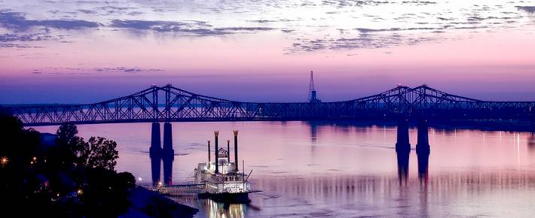 For three or four months in the year, you can walk across long parts of the Mississippi; in fact, you can walk along it too, or drive horses across it.

Motionless in the winter's icy ***grip***, the surface of North America's most famous river lies hidden for weeks on end beneath a cold white blanket of snow.

But below the surface the water flows on in silence, moving ***relentlessly*** through the frozen heartland of North America, towards warmer and more colorful lands.

"Old Man River" is no more than a child in the state of Minnesota, where he is born among the lakes and the forests not far from the Canadian border. If he had chosen to move north or west, he would have finished up in the Atlantic Ocean, part of America's other great river, the Saint Lawrence. But the child that is to turn into Old Man River moves south.

 He makes his way towards the Gulf of Mexico. It's a distance of 1,500 miles as the crow flies, but more like 2,500 miles along the ***meandering*** course that he chooses. It will be several weeks before the waters that rise in Minnesota eventually flow out past the ocean-going ships tied up at [**New Orleans**](https://linguapress.com/advanced/mardi-gras-orleans.htm), and ***mingle*** with the salt of the sea.

Of course, Old Man River has been making more or less the same southward journey for thousands of years: long before anyone thought of calling him "Old Man River", he had no name. It was the Algonquin Indians who gave him the name "Mississippi"; in their language, the name meant Great River. The name has stuck.

The first European to set eyes on the great river was a Spanish explorer, called De Soto, who came across the mouth of the river in 1541; yet it was not until over a century later that the Mississippi river began to take a significant place in the history of North America. In 1682 a French explorer called La Salle ***set off from*** the Great Lakes region, followed the Ohio river, and eventually reached the coast. Having established an alternate route from the Great Lakes to the sea, La Salle claimed the whole of the Mississippi basin for the French king Louis XIV, and called it Louisiana in his honour.

For almost a century, the Mississippi valley was French territory, sandwiched between the British colonies to the east, and "New Spain" and the unexplored prairies to the west. Little French colonies appeared along the banks of the river, but in most cases their names are the only things about them that remain from their early days: St. Cloud, La Crosse, Prairie du Chien, St. Louis, and many more. It is only at the mouth of the river, round New Orleans and Baton Rouge, that the river's French past still lives on, to a limited degree. New Orleans' "Mardi Gras" celebrations are among the most colorful in the United States, a ***hybrid*** fusion of old French tradition and Afro-American celebration.

In 1783, the land to the east of the Mississippi became the western frontier of the newly born United States of America. As for the much larger area of land to the west, it was sold to the United States by Napoleon in 1803, for the sum of $11.5 million, in the historic "Louisiana Purchase".

Nevertheless, even before the Louisiana Purchase, American settlers had begun pushing across the river, searching for places to ***settle*** in the virgin territory beyond. And as the great wide valley filled up with more and more farms, towns and markets, so the importance of the river grew.

During the cotton boom of the early nineteenth century, the river and its tributaries allowed plantation owners to get their produce easily down to New Orleans, where it could be exported to markets all over the world, and particularly to the textile ***mills*** of Lancashire, England.

## DANGEROUS MISSISSIPPI

     The Mississippi drains a basin that covers 41% of the continental United States (excluding Alaska), stretching from Montana in the West to New York in the East. It is the third largest river basin in the world, after the Nile and the Congo.  
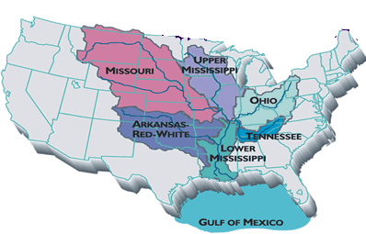    With such a large continental basin, the Mississippi is a river whose ***flow*** can be ***erratic***; at the mouth of the river, the average flow is about 13,000 cubic metres per second. However, experts estimate that the maximum flow could reach 85,000 cubic metres per second under exceptional circumstances; currently, river engineers are working on "Project Flood", to make sure that outlets into the Gulf of Mexico can cope with a flow of this magnitude.  
    The risks of flooding have been clearly understood from the day people first began to settle beside the river. Many of the towns and settlements beside the river are situated on "***bluffs***", others are protected. It was French engineers who first began protecting the land beside the river by building up long ***dikes***, which they called "levees", a French word meaning "raised banks"; today, thousands of square miles of farmland and dozens of towns and  are protected by levees.  
    Most of the time, the levees do their job; but not always. In 1993, hundreds of square miles of land were flooded, and millions of dollars' worth of damage done when the mighty river became too mighty, and broke through the defenses.

**WORDS**

**grip:***hold* **- relentless:***unstoppable, irresistable****-*meander:***curve continually***- mingle:***mix***-  set off:***depart***-  hybrid:***mixed***- settle:***establish a home***-  mills:***factories***-  flow:***flux, movement of water  -*  **erratic:***unpredictable*-  **bluff:** *small hill* -  **dike**: *levee, embankment*

**The Mighty Mississippi**  
  
**Blank-fill exercise:**

*Try to complete this extract from the text using the original words.****Some****of the words you will need are in this list; but not all of them!  And be careful: this list also contains words you will not need!*  
  
    *actually   currently  larger  largest  many  most  much  outlets  outputs  so  such  that  what   which   whose*

    The Mississippi drains a basin __________ covers 41% of the continental United States (__________ Alaska). It is the third __________ river basin in the world, after the Nile and the Congo.    With __________ a large continental basin, the Mississippi is a river __________ flow can be erratic; at the mouth of the river, the __________ flow is about 13,000 cubic metres __________ second. However, experts estimate that the __________ flow __________ reach 85,000 cubic metres __________ second under exceptional circumstances; __________, river engineers are working on "Project Flood", to make sure that __________ into the Gulf of Mexico can __________ __________ a flow of __________ magnitude.    __________ of the towns and settlements  __________ the river are situated on "bluffs", others are protected by levees. __________ of the time, the levees do their job; but not __________ . In 1993, hundreds of __________ __________ of land were flooded, and millions of dollars' __________ of damage done when the mighty river became __________ mighty, and broke __________ the defenses.